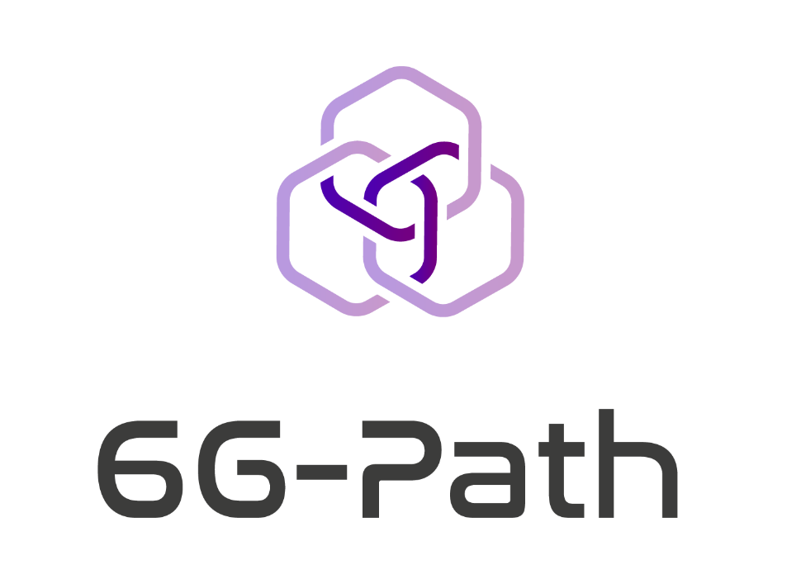

Annex 2.2
Technical Proposal
template

6G-PATH – Open Call #1

PROPOSAL TEMPLATE - INSTRUCTIONS

Read carefully before preparing your proposal:

IMPORTANT: The present Technical Proposal can only be submitted having already submitted the Feasibility Assessment Form and having received the feedback form the 6G-PATH consortium.
You must use this template to prepare your proposal and respect the structure. It has been organised to ensure that the important aspects of your planned work are measurable with respect to the evaluation criteria. Sections 1 to 4 of this template each correspond to an evaluation criterion (see Annex 1 – Guidelines for Applicants).
Applicants using another template/ document structure will be automatically disqualified. Only those proposals that successfully address all the required aspects included in the template will have the opportunity to be funded.
Please complete the Proposal identification page thoroughly.
The page limit for the proposal (Sections 1-4) is 12 pages (this limit excludes the template cover page, proposal identification page, the Summary and Ethics and Security sections).
Formatting requirements: Tables are allowed but must be included within this page limit. The minimum font size allowed is 10 points (in Calibri, current font) or 11 points (in Arial) (Note: tables can use font size 9 Calibri; 10 Arial). The page size is A4, and all margins (top, bottom, left, right) should not be changed from their current setting. Paragraph spacing should be a minimum 0pt before/ after, and 1pt line spacing. Black must be used as the font colour to facilitate readability.
The proposal must be uploaded in .PDF format. Failure to do so may result in exclusion. Pages beyond the defined page limit will not be taken into consideration by the experts and could result in parts of the proposal not being evaluated.
Please delete this page and the previous 6G-PATH cover before submitting the proposal. Your proposal should start with the PROPOSAL IDENTIFICATION PAGE (next page). Delete the guidance/ information text in yellow in each section and any template footnotes.

PROPOSAL IDENTIFICATION

PROPOSAL INFORMATION
Project Acronym | Write here as provided in F6S form, question X
Project Title | Write here as provided in F6S form, question X
Selected TRACK | Write here as provided in F6S form, question X

APPLICANT INFORMATION (Full legal names) |  | COUNTRY
Lead Beneficiary | As provided in the F6S form, question X
Beneficiary 2 (Only complete if applying as a consortium in TRACK A) | As provided in the F6S form, question X

SUMMARY OF THE PROJECT
NOTE: MAXIMUM OF 1 PAGE
Provide a full public summary of the project that can be published if the project is funded. Please provide information on the context your proposal is addressing, the main objectives, key activities and expected results.

TECHNOLOGY CONCEPT
NOTE: PAGE COUNT STARTS HERE
Describe how your project is aligned with the 6G-PATH project and (if applicable) the open call area that it addresses. You must also describe:
- Alignment of the proposal with the 6G-PATH project and the area being addressed.
- Description of the proposed solution and how it is novel or not yet widely deployed.
- Project objectives (general and specific).
- Starting and expected Technology Readiness Level (TRL), and respective rationale.

IMPACT & INNOVATION POTENTIAL
Describe the overall impact of the project, which must address:
- Description of the ambition and a clear set of expectations aligned with the objectives of the OC.
- Contribution to the broader goals of the 6G-PATH project in fostering industry transformation, resilience, and sustainability.
- Quantitative and qualitative overview, with examples, of the long-term impact in the form of market potential and scalability.
- Anticipated societal or economic benefits that the project aims to bring about.
- Measures to exploit results and promote the project.

IMPLEMENTATION
Describe the workplan and how you will implement the project. You must also describe:
- Description of the project work plan, including alignment of outcomes with proposed objectives; description of barriers/ risks that may affect the workplan (consider using the tables below to support the description).
- Specify proposed Key Performance Indicators (KPIs), emphasising that these will be refined and expanded in Phase I. Include technical and business metrics linked to project milestones, as KPIs will trigger staged payments.
- For Track B proposals: please specify the testbed or testbeds targeted by the proposed extension and describe what features/functionalities from the testbed(s) are required for integrating your extension.
- Present a detailed description and completed table on rationale for project costs, incorporating information on the team and other resources. Proposals must explicitly define how milestones, linked to KPIs, will trigger staged payments. The budget should be transparent, demonstrating good value for money.

Table 1. Suggested table for description of activities
Activity name | Description | Planned outputs | Planned duration
Activity 1
Activity 2
Activity x
NOTE: Add lines (for activities) as required
Table 2. Suggested table for description of KPIs
KPI number and name | Description | Value(s) | Timing
KPI 1 – Title
KPI 2 – Title
KPI x – Title
NOTE: Add lines (for KPIs) as required
Table 3. Suggested table for description project costs
Cost category | Total | Description
[A] Direct personnel costs
[B] Travel costs
[C] Equipment costs
[D] Other direct costs
[E] Indirect costs
TOTAL PROJECT COSTS | Insert value here

TEAM SKILLS & EXPERIENCE
Provide a comprehensive overview of the project implementation team, highlighting their collective skills and expertise. Include the following:
- Description of the track record and areas of expertise of consortium members, emphasising technical capabilities crucial for the successful development of the proposed solution.
- Demonstrate the team's commitment to gender balance within its composition.
- Showcase the team's capacity, skills, and expertise to not only execute the proposed plan effectively but also emphasise the potential for scalability of the application concept. This includes extending beyond use-case implementation, both internally and externally, across various sectors and domains.

Table 4. Suggested table for description of consortia/ team
Name of Person (M/F/O)  (Entity short name) | Role in the project and areas of expertise | Link to CV/ LinkedIn
Person name 1 (M/F/O)  (Entity short name) |  | Link
Person name 2 (M/F/O)  (Entity short name) |  | Link
Person name X (M/F/O)  (Entity short name) |  | Link
M (Male), F (Female), O (Other)
Table 5. Suggested table for distribution of PMs for team
Name of Person | PMs | Name of Person | PMs
Person name 1 |  | Person name 1
Person name 2 |  | Person name 2
Person name X |  | Person name X
TOTAL PMs | Insert value here

ETHICS & SECURITY
NOTE: PLEASE FILL OUT THE ETHICS/ SECURITY CHECKLIST ON THE FOLLOWING PAGE (PROVIDE A YES/NO FOR EACH ITEM).
This section is NOT covered by the 12-page limit.

Ethics
If you have entered any ethics issues in the Ethics/ Security checklist, you must:
- Submit an ethics self-assessment, which:
  - Provides a rationale for the option made.
  - Describes how the proposal meets the national legal and ethical requirements of the country or countries where the tasks raising ethical issues are to be carried out.
  - Explains in detail how you intend to address the issues in the ethical issues table, as regards:
    - Research objectives (e.g., study of vulnerable populations, dual use, etc.).
    - Research methodology (e.g., clinical trials, involvement of children and related consent procedures, protection of any data collected, etc.).
    - The potential impact of the research (e.g., dual use issues, environmental damage, stigmatisation of particular social groups, political or financial retaliation, benefit-sharing, malevolent use, etc.).
- Provide the documents that you need under national law (if you already have them), e.g.:
  - An ethics committee opinion.
  - The document notifying activities raising ethical issues or authorising such activities.

If these documents are not in English, you must also submit an English summary of them (containing, if available, the conclusions of the committee or authority concerned).
If you plan to request these documents specifically for the project you are proposing, your request must contain an explicit reference to the project title.

Security
Please indicate if your project will involve:
- Activities or results raising security issues: [YES/NO]
- “EU-classified information” as background or results: [YES/NO]
- Any potential “dual use” of results: [YES/NO]

Ethics/ Security Checklist
YES / NO
Informed consent
Does the proposal involve children?
Does the proposal involve patients or persons not able to give consent?
Does the proposal involve adult healthy volunteers?
Does the proposal involve Human Genetic Material?
Does the proposal involve Human biological samples?
Does the proposal involve Human data collection?
Research on human embryo/foetus
Does the proposal involve Human Embryos?
Does the proposal involve Human Foetal Tissue / Cells?
Does the proposal involve Human Embryonic Stem Cells?
Privacy
Does the proposal involve processing of genetic information or personal data (e.g., health, sexual lifestyle, ethnicity, political opinion, religious or philosophical conviction)
Does the proposal involve tracking the location or observation of people?
Research on animals
Does the proposal involve research on animals?
Are those animals transgenic small laboratory animals?
Are those animals transgenic farm animals?
Are those animals cloned farm animals?
Are those animals nonhuman primates?
Research involving developing countries
Use of local resources (genetic, animal, plant etc.)
Benefit to local community (capacity building i.e., access to healthcare, education, etc.)
Dual use
Research having direct military application
Research having the potential for terrorist abuse
ICT implants
Does the proposal involve clinical trials of ICT implants?
I CONFIRM THAT NONE OF THE ABOVE ISSUES APPLY TO MY PROPOSAL

A PM is a metric for expressing the effort of a person dedicated full time in one month.

