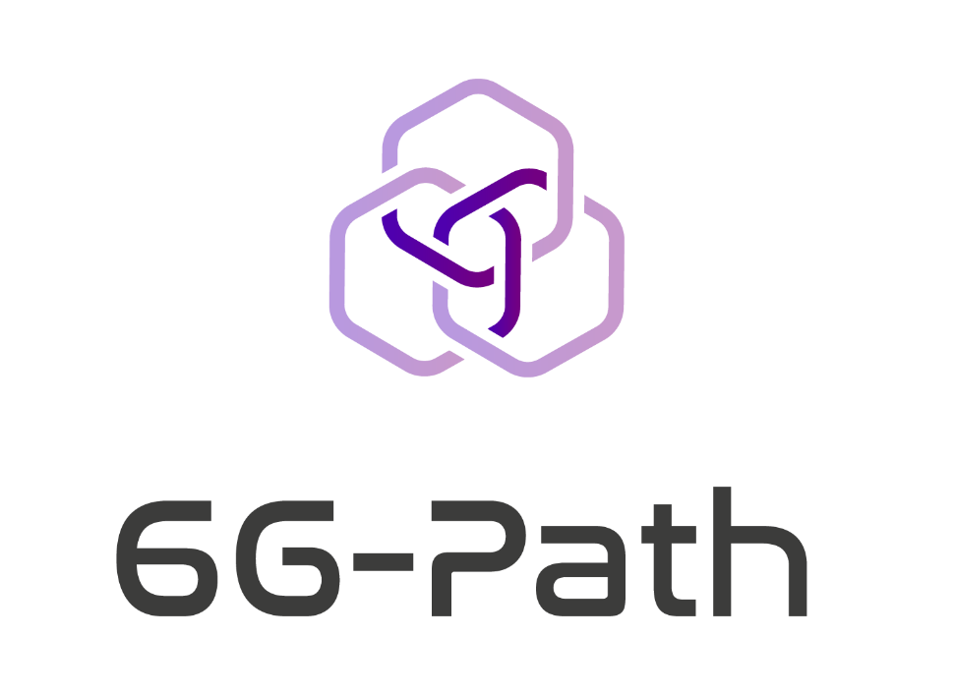

Annex 2.1
Feasibility assessment form

6G-PATH – Open Call #1

FEASIBILITY SUBMISSION TEMPLATE - INSTRUCTIONS

Read carefully before preparing your submission:
You must use this template to submit the feasibility assessment. Applicants using another template/ document structure will be automatically disqualified.
In case of a project submitted by a consortium, the form must be filled by the Lead beneficiary.
The feasibility assessment form is built following the same structure as the Annex 2.2 “Technical Proposal template” to harmonise the data gathered during the feasibility check and the final submission phase.
The feasibility assessment form consists of mandatory questions marked with a red asterisk (*) and optional questions.
Only those proposals that successfully address all the mandatory questions will be considered eligible for the feasibility assessment.
Note that the feasibility assessment is a mandatory step required for the submission of the final proposal using Annex 2.2.
Each applicant submitting the feasibility assessment form will receive feedback from the 6G-PATH consortium within 8 working days. The feedback provided by the 6G-PATH consortium should be considered when completing the full application form in order to better adapt the project technical settings.
Only after receiving the feedback to the feasibility assessment can you proceed in submitting the full project proposal.
The page limit for this form is 10 pages (including both the mandatory and non-mandatory questions). Tables are allowed but must be included within this page limit. The minimum font size allowed is 10 points (in Open Sans, current font) or 11 points (in Arial) (Note: tables can use font size 9 Open Sans; 10 Arial). The page size is A4, and all margins (top, bottom, left, right) should not be changed from their current setting. Paragraph spacing should be a minimum 0pt before/ after, and 1pt line spacing. Black must be used as the font colour to facilitate readability.
The proposal must be uploaded in .PDF format. Failure to do so may result in exclusion. If you attempt to upload a proposal longer than the specified limit, pages beyond the limit will not be taken into consideration by the experts and could result in parts of the proposal not being evaluated.

Please delete this page and the previous 6G-PATH cover page before submitting the form. Your submission should start with the FEASIBILITY ASSESSMENT COVER PAGE (next page).

FEASIBILITY ASSESSMENT COVER PAGE

PROPOSAL INFORMATION
Project Acronym | Write here as provided in F6S form, question X
Project Title | Write here as provided in F6S form, question X
Selected TRACK | Write here as provided in F6S form, question X

APPLICANT INFORMATION (Full legal names) |  | COUNTRY
Lead Beneficiary | As provided in the F6S form, question X
Beneficiary 2 | As provided in the F6S form, question X

SUMMARY OF THE PROJECT*
NOTE: MAXIMUM OF 1 PAGE
Provide a full public summary of the project that can be published if the project is funded. Please provide information on the context your proposal is addressing, the main objectives, key activities and expected results.

TECHNOLOGY CONCEPT*
NOTE: PAGE COUNT STARTS HERE
Describe how your project is aligned with the 6G-PATH project and (if applicable) the open call area that it addresses. You must also describe:
- Alignment of the proposal with the 6G-PATH project and the area being addressed*
- Description of the proposed solution and how it is novel or not yet widely deployed.*
- Project objectives (general and specific).*
- Starting and expected Technology Readiness Level (TRL), and respective rationale.

IMPACT & INNOVATION POTENTIAL
Describe the overall impact of the project, which must address:
- Description of the ambition and a clear set of expectations aligned with the objectives of the OC.
- Contribution to the broader goals of the 6G-PATH project in fostering industry transformation, resilience, and sustainability.
- Quantitative and qualitative overview, with examples, of the long-term impact in the form of market potential and scalability.
- Anticipated societal or economic benefits that the project aims to bring about.
- Measures to exploit results and promote the project.

IMPLEMENTATION*
Describe the workplan and how you will implement the project. You must also describe:
- Description of the project work plan, including alignment of outcomes with proposed objectives; description of barriers/ risks that may affect the workplan (consider using the tables below to support the description).*
- Specify proposed Key Performance Indicators (KPIs), emphasising that these will be refined and expanded in Phase I. Include technical and business metrics linked to project milestones, as KPIs will trigger staged payments.*
- For Track B proposals: please specify the testbed or testbeds targeted by the proposed extension and describe what features/functionalities from the testbed(s) are required for integrating your extension.*

Table 1. Suggested table for description of activities
Activity name | Description | Planned outputs | Planned duration
Activity 1
Activity 2
Activity x
NOTE: Add lines (for activities) as required

Table 2. Suggested table for description of KPIs
KPI number and name | Description | Value(s) | Timing
KPI 1 – Title
KPI 2 – Title
KPI x – Title
NOTE: Add lines (for KPIs) as required

